**SOAL TES TULIS**

1. 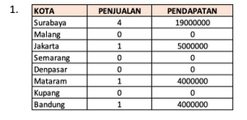

**Jawaban no 1:**

select ct.name as kota, sum(td.qty) as penjualan

left from transactiondetails td join transactions tr

on td.invoiceid = tr.id

left join customers cr

on tr.customerid = cr.id

left join cities ct

on cr.cityid = ct.id

left join items it

on it.id = td.itemid

group by kota

1. 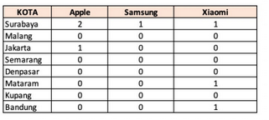

**Jawaban no 2**

Select name (select count(transactiondetails.id) join transactions on transactions.id =

Transactiondetails.invoiceid join customers on customer.id =transactions.customer.id

Where customerid.cityid =cities.id and

Transactiondetails.itemid=1) as Apple, (select

Count(transactiondetails.id)join transactions on transaction .id = transactiondetails.invoiceid join customers on customer.id = transactions.customerid where

Customerid.cityid = cities.id and

Transactiondetails.itemid=2) as Samsung,(select

Count(transactiondetails.id)join transactions on transaction.id = transactiondetails.invoiceid join

Customers on customer.id =transactions.customerid where customerid.cityid = cities.id and

Transactiondetails.itemid=3) as xiaomi from cities.

1. 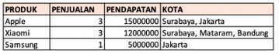

**Jawaban no 3:**

select name, (select count(transactiondetails.id) join

join transactions on transaction.id =

transactiondetails.invoiceid join customers on

customer.id =transactions.customerid where

transactiondetails.itemid=items.id) as penjualan,

(penjualan * item.price) as pendapatan, (select

GROUP_CONCAT(cities.name ‘,’) join transactions on

transaction.id = transactiondetails.invoiceid join

customers on customer.id = transactions.customerid join

cities on cities.id = customer.cityid where

transactiondetails.itemid=items.id group by null) as kota from items